May 25 - 26, 2024

Pre-Ride the 2024 AERC National Championship trails! www.maryandannamemorialride.com

LOCATION:
Outback Station Event Center
76231 Hwy 31

La Pine, OR 97739 DIRECTIONS:
Hwy 97 from La Pine: 1 mi south of La Pine, turn onto Hwy 31. Go to 25 mile marker, watch for signs. Left towards Outback Station, go 1 mile. Ridecamp to the left.

CAMP:
A large acreage meadow with easy parking for big rigs. Located directly off a well traveled paved road.
Camping Fees: $15/night
Corrals: Limited number of pens available.
Pens will be awarded by lottery. See website for details.

TRAIL:
USFS & BLM roads and trails. Some elevation change, no steep ups or downs. Plentiful water will be available on the trail!
IDEAL first 100 miler for horse and rider! RULES: ALL AERC RULES APPLY.
Spread hay & manure, fill any holes dug by your horse. Clean your campsite before leaving.
See a complete list of rules on our website. ALL RIDERS WILL BE REQUIRED TO WEAR HELMETS WHEN MOUNTED.

RIDE MANAGER INFORMATION
Ride Managers: Max & Darlene Merlich
Trails:

DISTANCES: 5/25: 25/50/75/100 ~ 5/26: 25/50 ENTRY FEES:
- Trail Ride: $35 ($40 PayPal)
- 25 Miles: $120 ($125 PayPal)
- 50 Miles: $120 ($125 PayPal)
- 75 Miles: $175 ($185 PayPal)
- 100 Miles: $220 ($230 PayPal)
All distances add $35 for registration/payment at ridecamp.
AERC fee applies to non-members
All riders under the age of 18 will ride free, thanks to the Mary and Anna Memorial Youth Fund.

PRE-REGISTRATION REQUESTED!
Entry Form and online registration will be posted on the website.
Pre-register online and send $25 nonrefundable check, made out to "TER Endurance",
to: Carol Giles
1304 NE Montana Lane Prineville, OR 97754.
Or you can pay $30 via PayPal (nonrefundable): paypal.me/terrides Pre-registration closes 5/13/24.
Balance paid via PayPal will be due by 5/20, or, by cash or check at the ride (Preferred!) NO ELECTRONIC PAYMENTS ACCEPTED AT THE RIDE

PROCEEDS FROM THIS RIDE TO BENEFIT THE

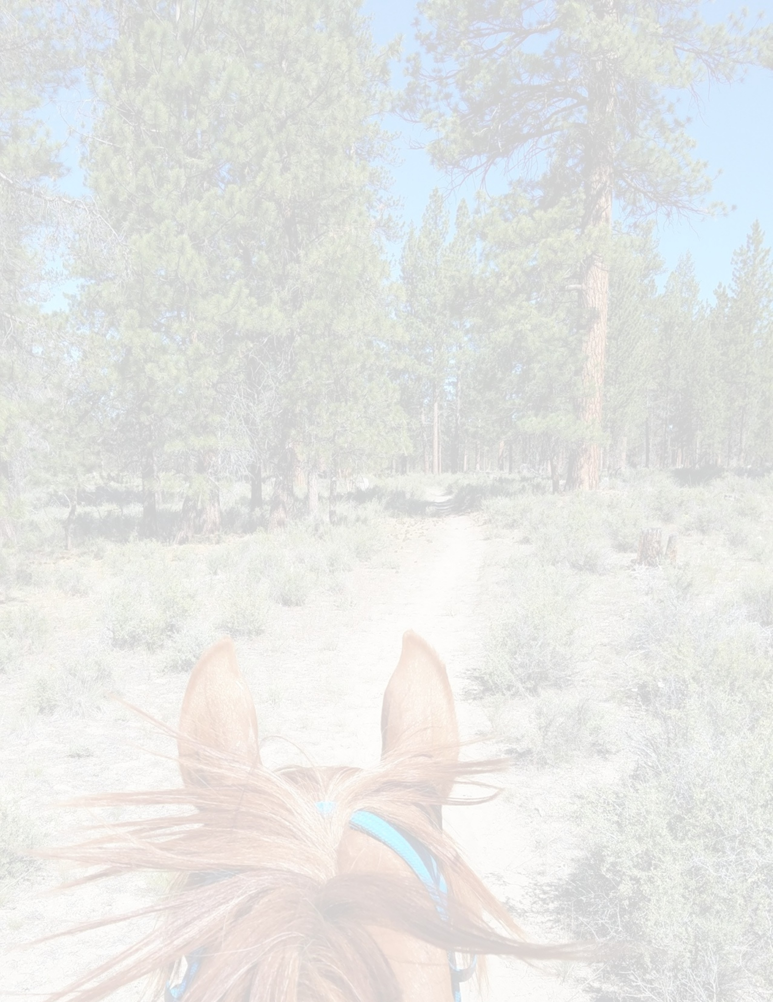
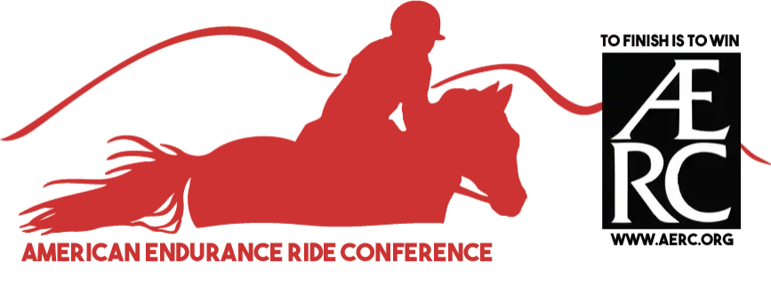
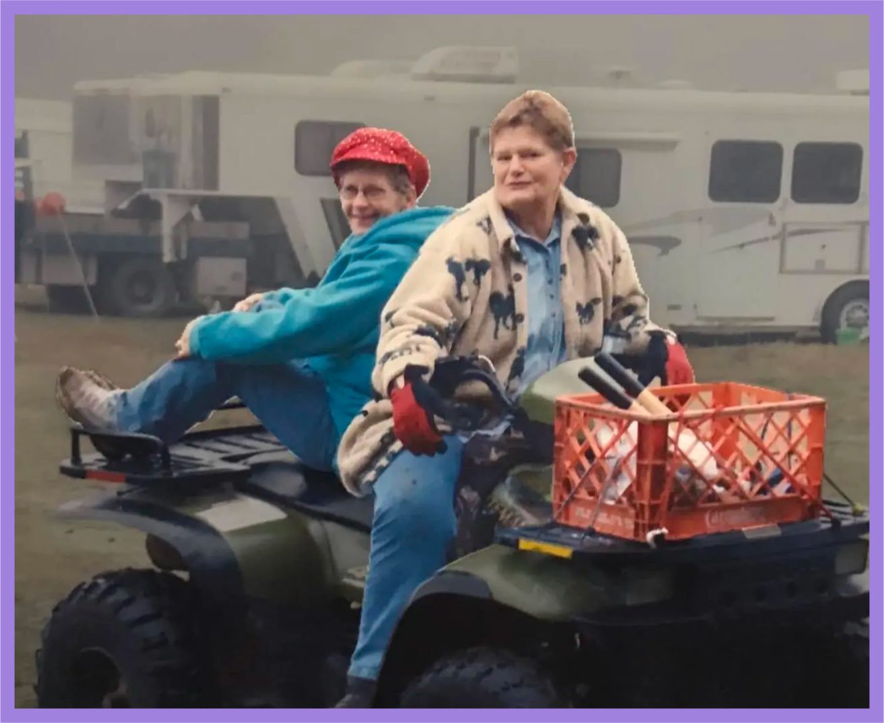
Max: 503-784-5337 / termaxm@gmail.com Darlene:
360-433-5772 / endrncrider@gmail.com Registration/entry fee payment questions:
Carol Giles (2024aercnc@gmail.com) Ride Secretary:
Shawna Bowin (sabowin@yahoo.com) Head Veterinarian: Dr Mike Foss

MARY & ANNA MEMORIAL YOUTH FUND!

Sanctioned by the American Endurance Ride Conference
The Mary & Anna Memorial Ride is operated under Special Use Permits with the Deschutes USFS and the BLM.

